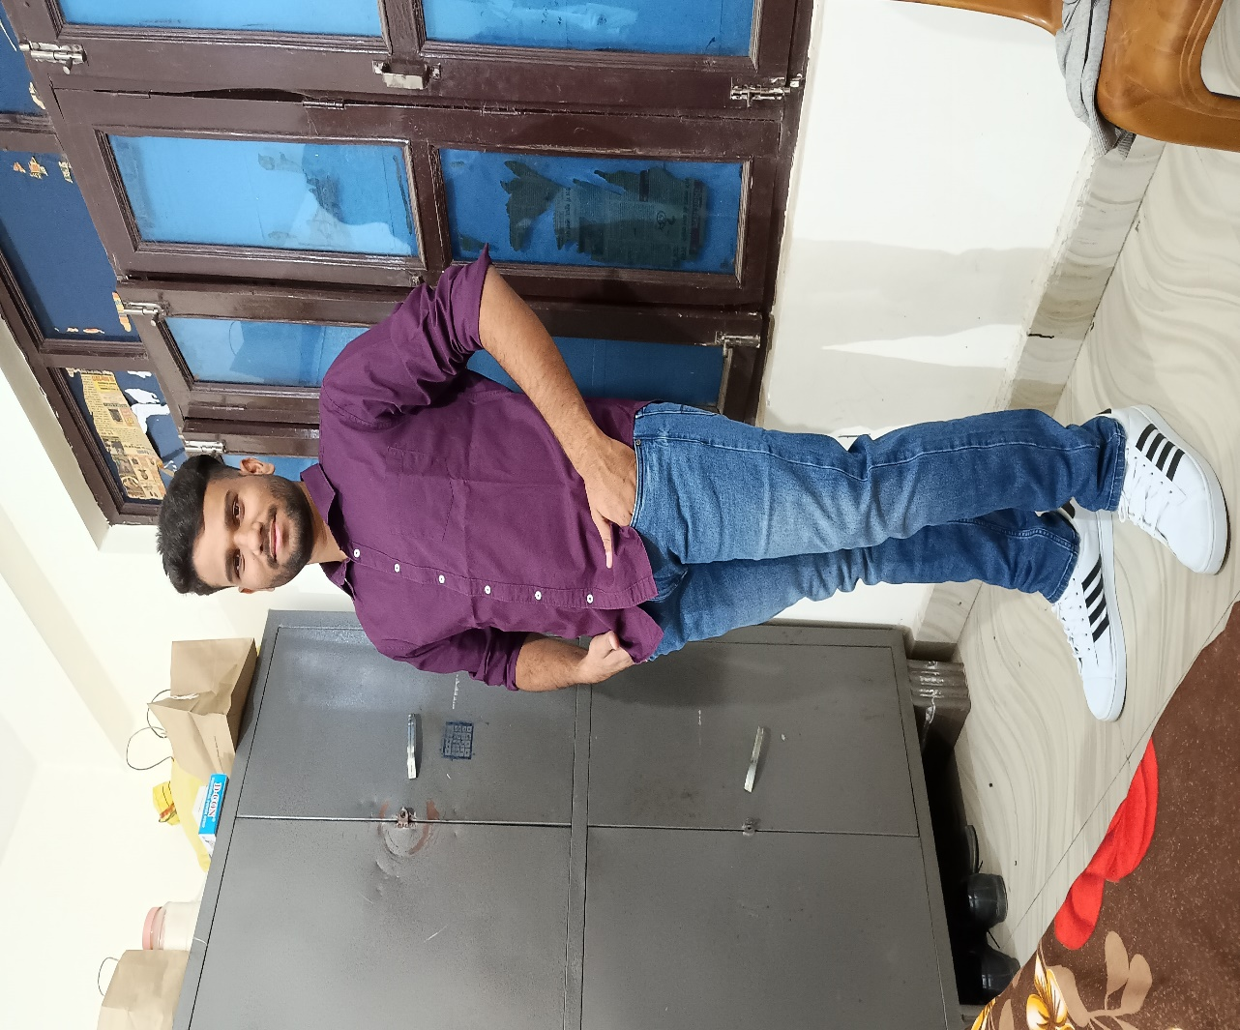

**Ayush Vikram Singh**

+91-6306240833

[ayushvikramsingh425@gmail.com](mailto:ayushvikramsingh425@gmail.com)

Lucknow(U.P)

|  |
| --- |
| Career Objective |

Seeking a challenging role at a reputed I.T organization to utilize my engineering skills that can contribute to the company’s growth as well as enhance my knowledge by exploring new things.

|  |
| --- |
| Technical Strength |

* Language : C , C# , Python , Html , .NetFrameWork , .NetCore WebApp
* Operating System :- Linux , Ubuntu
* Database :- MySql , RDBMS
* Cloud Computing , AWS

|  |
| --- |
| Subject Of Interest |

* Cyber Security
* Cloud Computing
* Database
* Web/App development
* Infrastructure

|  |
| --- |
| Projects |

* My Task Manager :- To Add New Client in WebApp or in a website using ASP.Netframework with help of CRUD Operation.
* Personal Portfolio Website.
* Weather App.
* Education Donation :- Ecommerce website using HTML , CSS , javascript.

|  |
| --- |
| Workshop/Certification |

* Getting started with Enterprise Data Science by IBM.
* IBM cloud Essential V3.
* Fundamental of .NET by ARCON TechSolutions.
* AWS

|  |
| --- |
| Experience |

* Intern Trainee at ARCON TechSolutions pvt.Ltd (Kamla Executive Park ,Andheri,Mumbai).
* Two weak Summer Training in IBM.
* Cloud Computing.
* PAM(Privileged Access Management).

|  |
| --- |
| Achievement |

* Zonal Level Kabaddi Certificate.
* Intercollege Cricket Certificate.
* Organizer Certificate from college

|  |
| --- |
| Educational Qualification |

* **Shri Ramswaroop College Of Engineering And Management**

2020 – 2024

B.Tech (I.T)

INFORMATION TECHNOLOGY

* **LUCKNOW PUBLIC SCHOOL**

***INTERMIDIATE***

2019 – 2020

***HIGH SCHOOL***

2017 – 2018

|  |
| --- |
| Personal Detail |

* Father’s name : Satya Narayan Singh
* Mother’s name : Suman Singh
* Date Of Birth : 20/08/2002
* Launguage Known : English , Hindi
* Address : Badlapur , Jaunpur ,U.P(222125)

|  |
| --- |
| Declaration |

I hereby declare that all the information mentioned above is true to best of my knowledge.

Place - Lucknow

Ayush Vikram Singh